Project Proposal
Personal Finance AI Agent (LangChain)

Author: Dhrubajyoti Ghosh

Contents

Brief on the Project 3
Features 4
Deliverables of the project 5
Model Selection 10
QnA 11
Model Information 12
Important Findings 12
Resources & Individual Details 15
Milestones 16

Brief on the Project
The purpose of this project is to develop an AI-powered financial assistant that help users to perform common personal financial calculations. This includes calculating the following:
- EMI against loan amount
This is done using the below formula:
EMI = P × r × (1+r) ^n / ((1+r) ^n - 1)
Where, P Loan Amount
r Monthly Interest Rate
n Number of months
- Investment returns
This is done using the below formula:
FV = P × ((1+r) ^n − 1) / r
Where, FV Future Value
P Monthly Investment
r Monthly Interest Rate
n Number of months
- Budget allocation based on income using 50-30-20 rule:
- 50% Needs
- 30% Wants
- 20% Savings
- Performing general mathematical operations
The AI assistant is developed using LangChain, large language models (LLMs) and custom calculation tools to assist users perform these tasks. Streamlit is used to design the UI that helps users to submit their queries in natural language and receive response accordingly. The AI assistant interprets this natural language financial queries from user and chooses the custom tool to provide accurate calculation-based responses. During development, performance of various LLMs were also assessed to identify their effectiveness and efficiency.

Features
Tools
The application utilises following 4 tools for various financial computations.
- Calculator Tool: It performs mathematical calculations based on the given input expression. It uses PythonREPL to evaluate the input text. Although financial evaluations primarily require basic arithmetic operations, the tool also supports other simple mathematical functions like logarithmic or trigonometric calculations.
- EMI Calculator Tool: Custom tool to calculate monthly instalment (EMI) for a loan based on loan amount, interest rate and tenure using the specified formula. The tool returns the monthly EMI, total interest payable and total amount payable over the loan tenure.
- SIP Calculator Tool: Custom tool to calculate the future value of monthly investments based on monthly investment, interest rate and duration using the specified formula. The tool returns total investment, estimated return and future value at the end of the specified duration.
- Budget Planner Tool: Custom tool to plan monthly budget against the user’s income using the 50-30-20 budgeting rule. Under this approach, 50% of income is allocated to needs, 30% to wants and 20% to savings.
Large Language Models (LLMs)
Following LLMs are used for evaluation and development:
- Google Gemma via Ollama - gemma4:e2b: Local Execution
- Meta Llama via Ollama - llama3.1:latest: Local Execution
- Google Gemini - gemini-3.8-flash: Cloud/API Execution
- OpenAI - gpt-4o-mini: Cloud/API Execution
Agents
Agents acts as an orchestrator that interprets the user’s natural language input and determines the appropriate tool to invoke based on the query. Here, four separate agents are configured. Each agent is associated with a different LLM to evaluate the performance. This approach helps in isolated testing, allows prompts to be customised independently for each LLM and provides better control over the behaviour of each model. This also simplifies selection of final model.

Deliverables of the project
- Jupyter Notebook: It contains the python code that does the following:
  - Importing and instantiating the agents used for evaluation.
  - Debugging the results to access accuracy and verify if the agents invoked the custom tools or generated the responses directly using LLM.
  - Comparing the performance and output of various agents powered by different LLMs.
  - Visualizing and presenting the comparative performance of the evaluated models.
- LLM File: It contains the definition and configuration of all the LLMs used in the application. It provides a centralized location for configuring and accessing the different models used by the agents for evaluation and execution.
- Tools File: It contains the definitions and implementations of all custom tools used by the AI agents. It provides the calculation and utility functions that agents can invoke to process user queries and generate accurate tool-based responses.
- Agents File: It contains the definitions and configurations of various agents, along with their corresponding prompts and tools assignments. It determines how each agent interprets user queries, selects the appropriate tools and generates responses using configured LLMs.
- Front end Code: It does the following:
  - Instantiates the agents required for processing user queries.
  - Uses Streamlit to provide an interactive user interface for accepting natural-language queries.
  - Displays the evaluated results generated.
  - Maintains the session history by storing user input and corresponding responses and displaying them in the interface.
- Requirements File: List of all libraries required to execute the application.
- Project Report File: A word document providing comprehensive overview of the project, outlining the approach used towards development of the financial AI assistant. The various challenges encountered during the process and the key factors that influenced selection of the final approach.
Approach Note
- The application is an AI powered financial assistant. It helps user to perform tasks using queries in natural language.
- After importing the required libraries, the preferred LLMs were defined.
- Among the models evaluated, “gpt-4o-mini” and “gemini-3.8-flash” used Cloud/API based execution. Hence, .env file was created that saves the API keys for respective GPT and Gemini models.
- All the LLMs were centralized in a single file for easy modifications and maintenance. This ensures consistency, reduced code duplication, and addition of new models for evaluation. This also helps to improve code readability.
- Similarly, all custom tools are defined in Tools file and agents are defined in Agents file.
- After defining the LLM file and loading the environment file in it, the Tools file was defined.
- In Tools file, PythonREPL was first instantiated for utilization in calculator tool. Using PythonREPL has a major challenge. As it allows python code execution, exposing this tool to untrusted users without proper restrictions may result in severe security vulnerability. It can potentially execute operating system commands or access sensitive information. Hence, necessary guardrails/restrictions must be provided in tool’s doctring and enforced at runtime.
- While deciding the approach to return the response or evaluated results, json format was selected. Various factors that lead to selection of json format are shared below:
  - The result consisted multiple pieces of information. For this scenario, structured json format is better than plain formatted string. It is easier for agents to understand and provides a better predictable format.
  - It is easier to process programmatically as values can be directly accessed.
  - It is better for combining multiple tools and enables consistent error handling. This makes building UI simpler later.
  - There are other options like Dict. Dict provides structured data, preserves python types, easier for multi-agent state and for programmatic operations. However, json is better option for transferring data across systems, if required. This helps in better code reusability.
- EMI calculation, SIP calculation and Budget planner tools were similarly developed using the respective predefined formulas. Well-structured docstrings, particularly the Args and Returns sections, were essential for defining tool inputs and outputs, handling responses effectively, and facilitating debugging. Args section clearly defined the parameters required by the tool, including their expected meaning and usage. Returns section specified the format and nature of the result generated by the tool. Well-defined docstrings helped the LLM correctly identify the required parameters and invoke the appropriate tool.
- Using a similar approach, the Agents file was defined to centralize the configuration of multiple agents. Multiple agents were maintained within the same file to ensure consistency and facilitate easy modification, following the same approach used for the LLM configurations. Each agent was associated with a specific LLM, while all agents had access to the common set of tools defined in the Tools file. This approach simplified agent management, promoted code reusability, and ensured consistent tool availability across the agents.
- Then, performance of various LLMs were evaluated to select the most suitable model. Based on model performance, OpenAI - gpt-4o-mini was finalised. As it required Cloud/API Execution, after deployment in streamlit cloud, the API key was moved to secrets.toml file from. env inside. streamlit folder.
- A new file llm_gpt.py was created that consisted definition of this OpenAI - gpt-4o-mini only. API Key of the model was redirected to the secrets.toml instead of. env. This was done to prevent interference from other models.
- Similarly, agent file was changed to agent_gpt.py which consisted agent that utilised this GPT model defined in llm_gpt.py and the tools defined in Tools file.
- Then, the UI of the AI assistant was developed using streamlit. Here, at first, the agents are instantiated. Then, session states are initialised followed by greeting message.
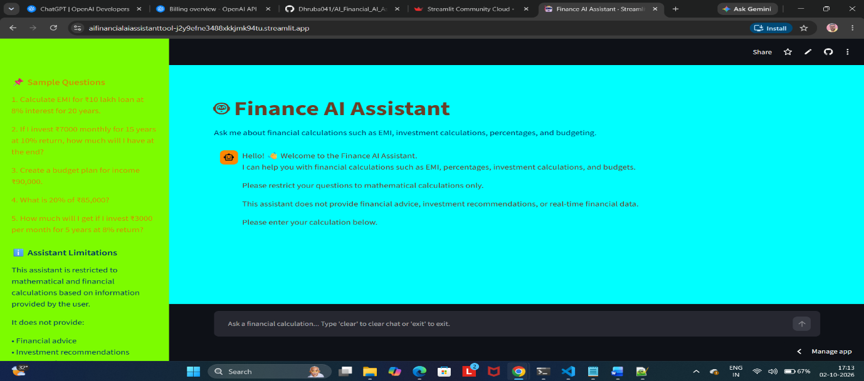
- The assistant is designed to preserve session history. Based on user’s input, the agent is invoked to perform the query evaluation using the respective tool.
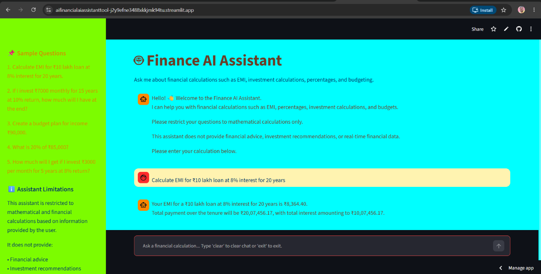
- After receiving the response, user may either provide another query or choose to exit. On exit, the session is ended with farewell message and user input section is disabled.
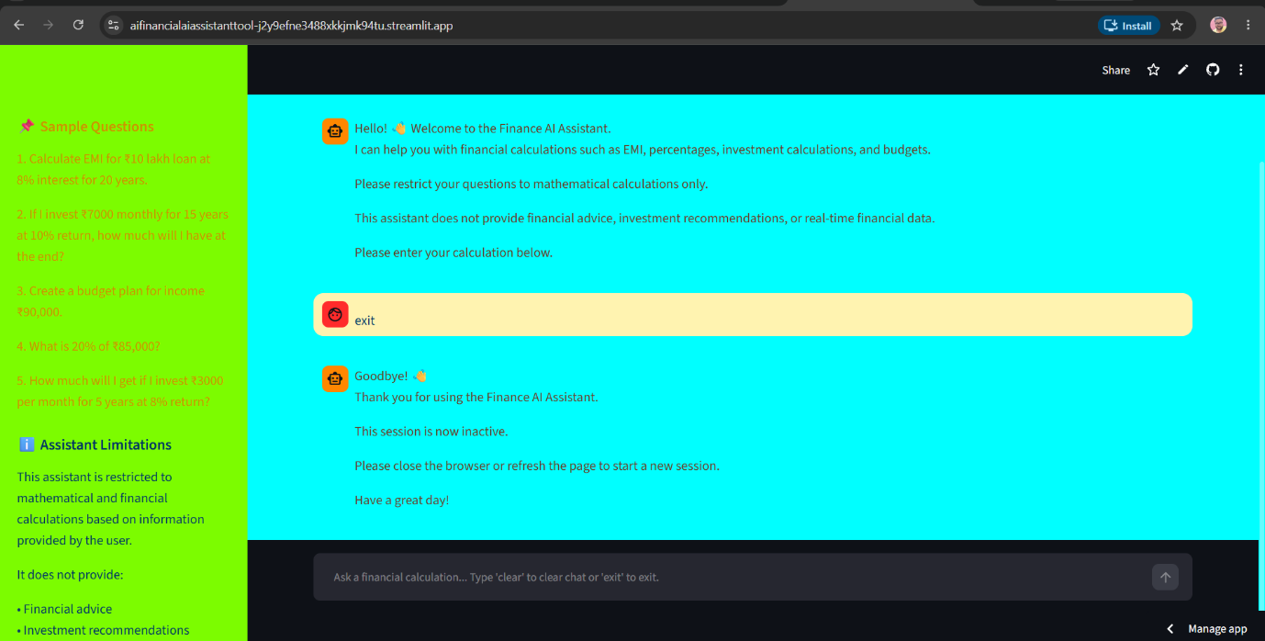
- In agent, the manner in which the chat prompt is defined is very important. It defines how the agent behaves and interacts with the tools. It enables proper orchestration by agents and ensures consistency.
- Being tool-based finance-focused AI assistant, it critical to ensure the LLM agents don’t generate AI messages but utilises the tool for response for every calculation. This is achieved through proper restrictions in chat prompts.
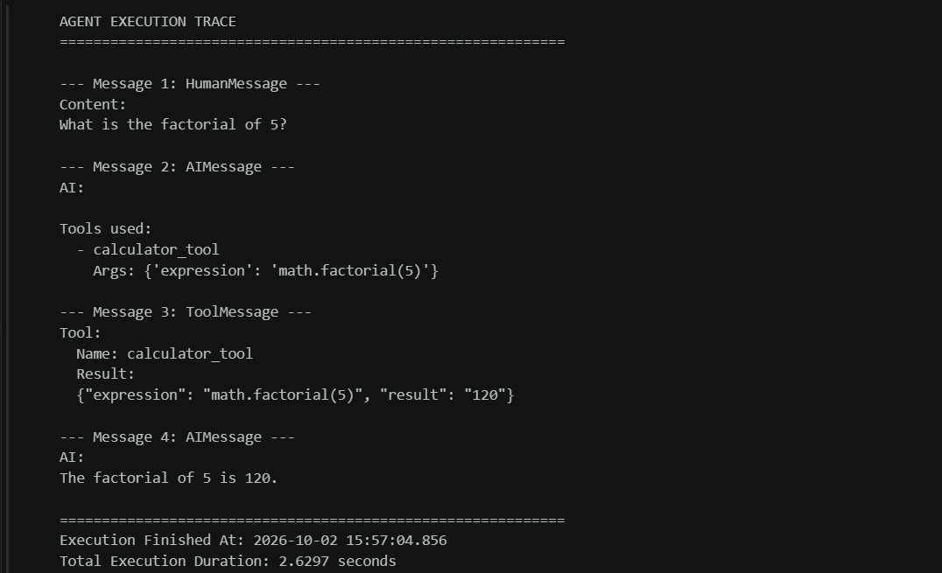
- The agent should neither answer any generic questions not it should share any real time information. This is again controlled through proper guardrails in chat prompts. Through guardrails, security of the AI assistant is also ensured. Agents should provide proper AI messages while throwing validation errors.
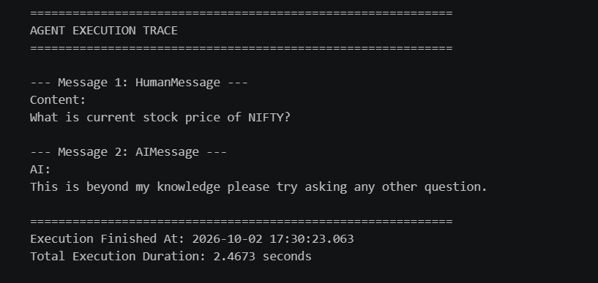

Model Selection
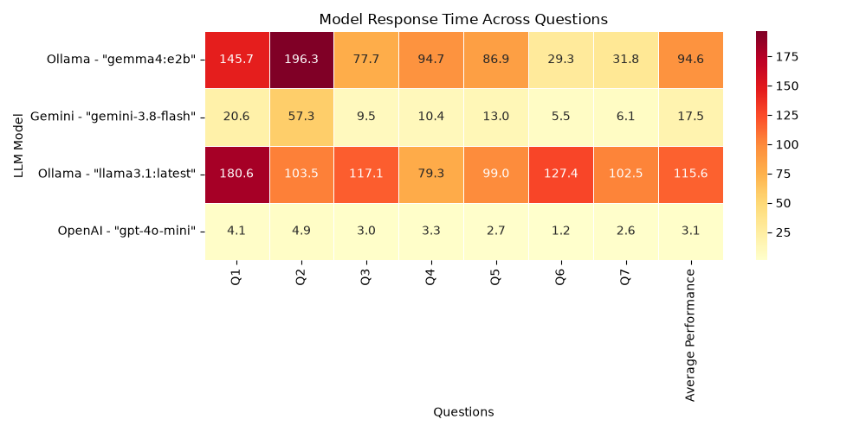
The following observations were made during the evaluation of the different LLMs:
  - "gpt-4o-mini" produced the fastest response amongst the evaluated models.
  - Response from "llama3.1:latest" was slowest.
  - In addition to these models, "gemini-3.7-flash" was also evaluated but its performance seemed comparable to "gemma4:e2b".
  - The free version of "gemini-3.8-flash" demonstrated significantly faster response with responses taking less than one-third of time observed for "gemini-3.7-flash".
  - A critical challenge observed with "gemma4:e2b" was inconsistent tool utilization. In 1 out of 5 executions, it generated a response directly without invoking the custom tool. When the same query was re-executed, the model invokes the appropriate tool.
  - Output of "gemini-3.8-flash" seemed more structured. However, "gpt-4o-mini" was chosen as the final model based on evaluation results.

QnA
Q1. Based on the performance of different LLMs against various questions, compare the performance of the custom tools?
Ans: Based on the below statistics, it was be said calculation using EMI calculation tool and SIP calculation tool required more time. The performance of calculator tool seemed relatively faster.
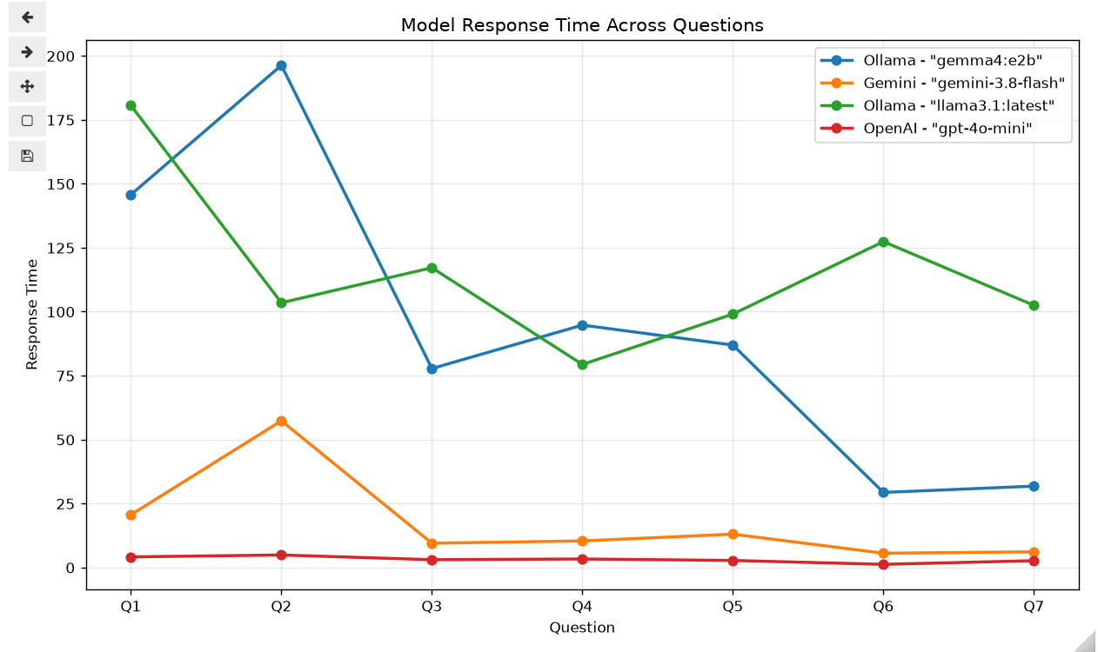
Q2. Evaluate average performance of the different models used?
Ans: Please refer the below figures for details.
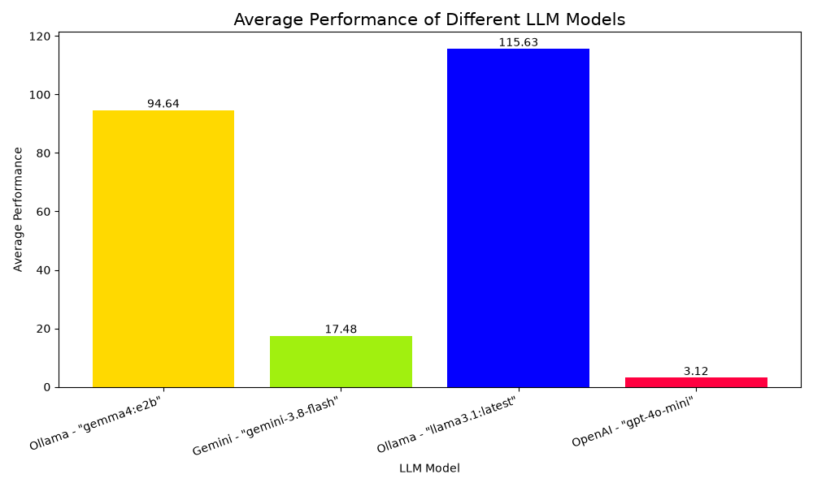

Model Information
LLM Used: OpenAI - gpt-4o-mini
Method of execution: Cloud/API Execution
Framework Used: LangChain
Python Version: 3.13
scikit-learn Version: 1.8.0

Important Findings
A challenge with the performance of "gemma4:e2b" was observed. In 1 out of 5 executions, the model generated response directly without invoking the appropriate custom tool. However, when the same query was re-executed, the model correctly invoked the appropriate tool. This indicates inconsistency of the model response. Additionally, the position of commands and guardrails in doc-strings played a key role for redirecting the user queries to respective tools instead of generating LLM based response. This was specifically observed in "llama3.1:latest" and "gemma4:e2b". However, this was not observed in other models evaluated.
Sample Output
Use of EMI Calculator Tool
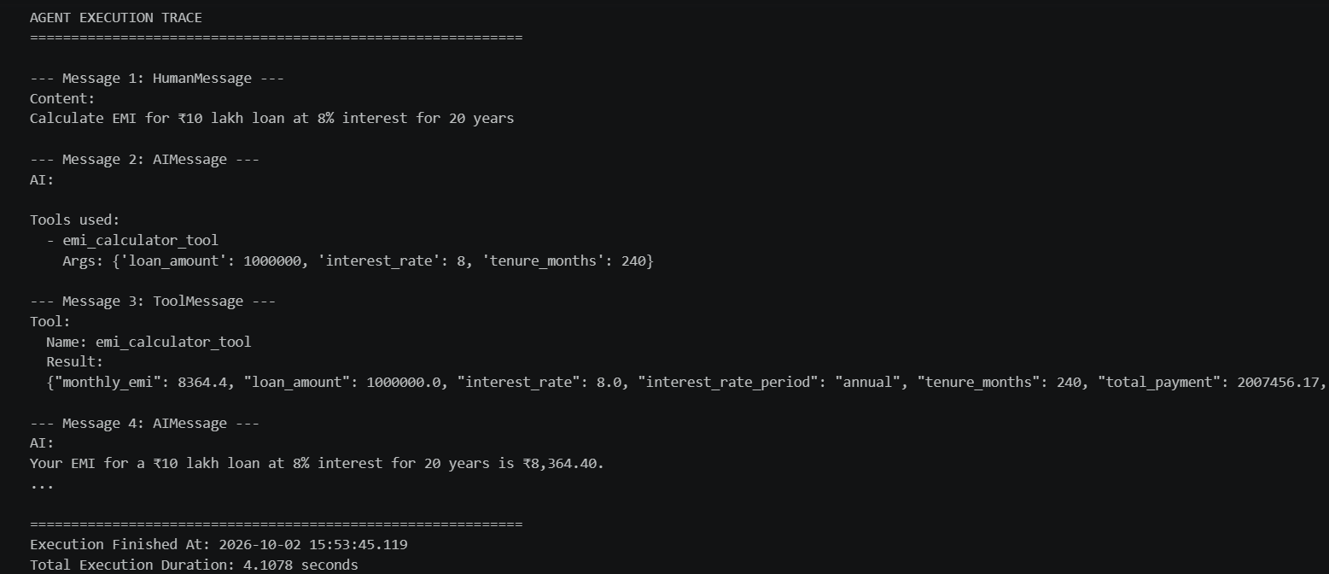
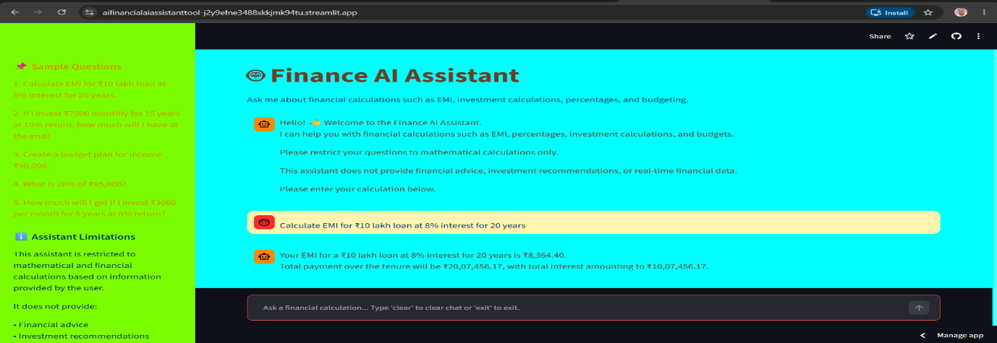
Use of SIP Calculator Tool
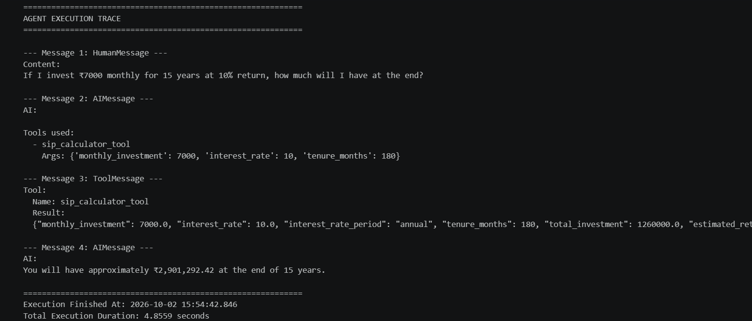
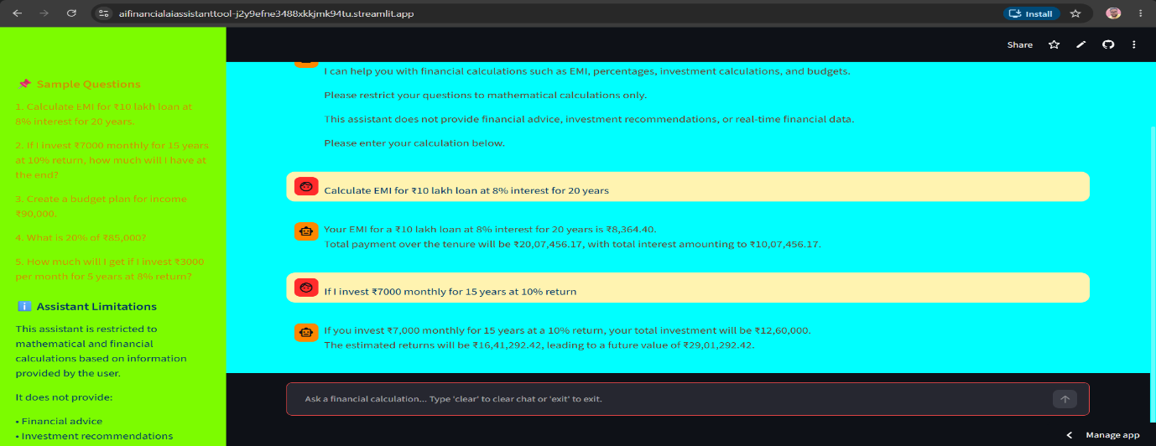
Use of Budget Planner Tool
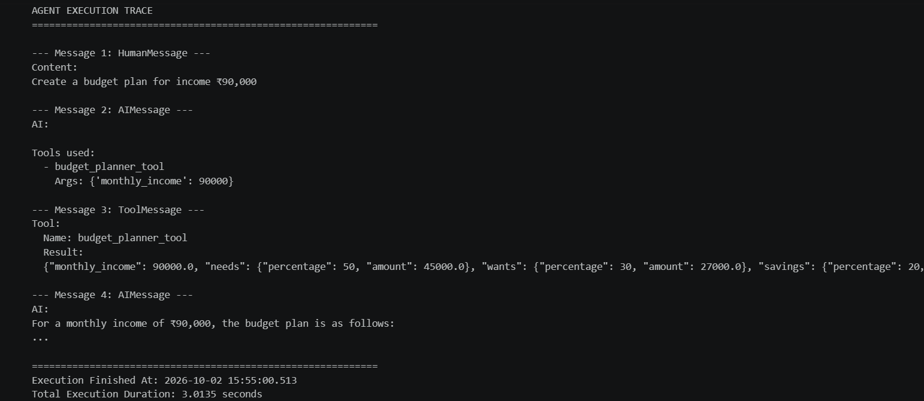
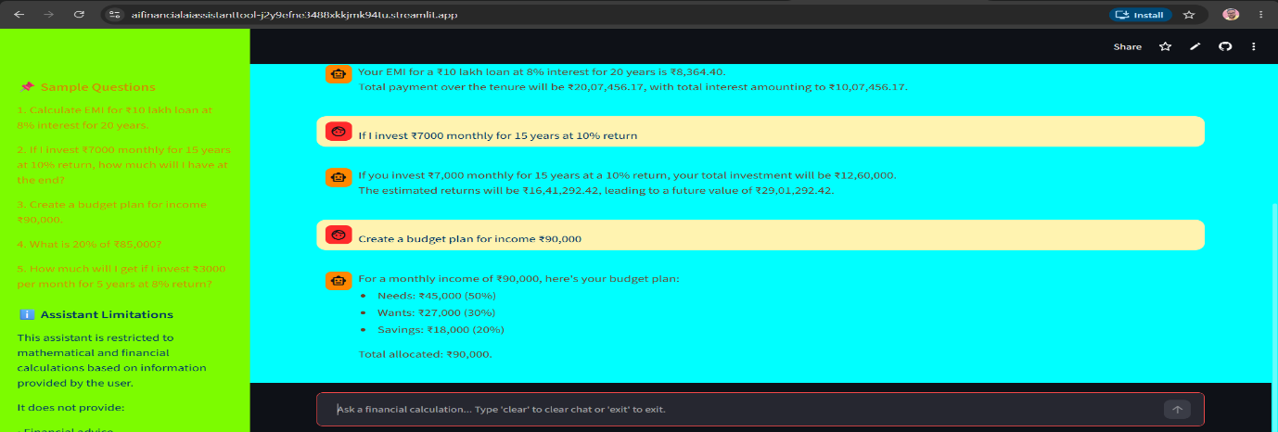
Use of Calculator Tool
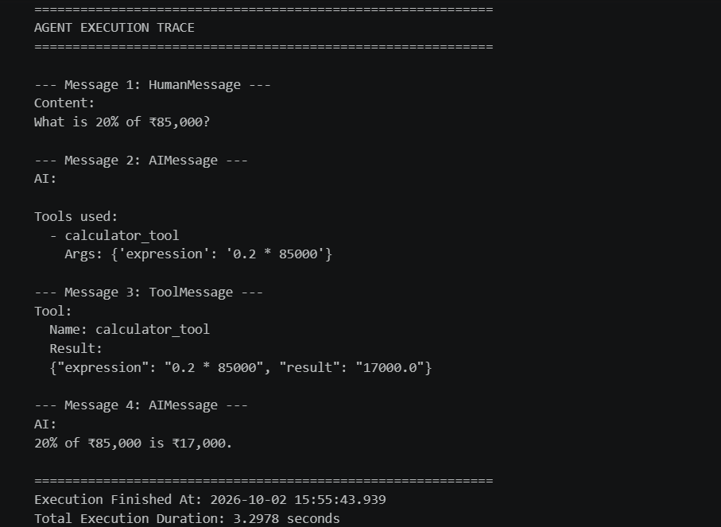
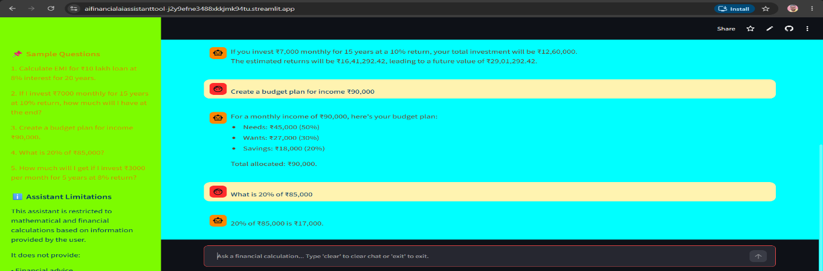
Validation Errors – Response to non-financial questions:
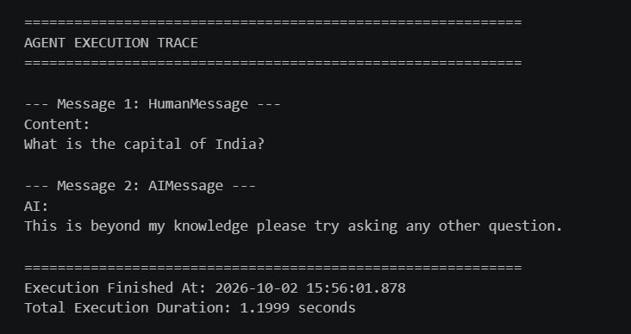
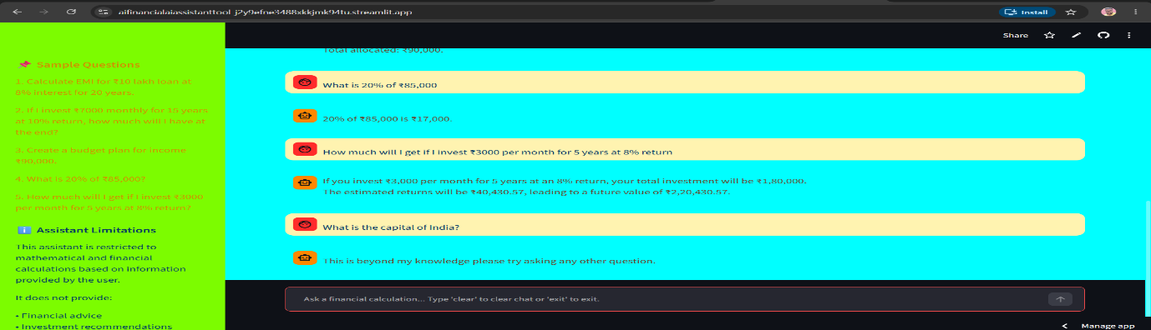

Resources & Individual Details
Data set source: This is not applicable.
Software: Jupyter Notebook, Visual Studio Code, Streamlit & GitHub
References:
- https://www.geeksforgeeks.org/
- ChatGPT
- Google Gemini
Individual Details:
Name: Dhurbajyoti Ghosh
Email: <DND>
Phone Number: <DND>
*DND – information not shared for data privacy

Milestones
Define a problem | Build an AI-powered Personal Finance Assistant using LangChain Agents and Tools to help users’ financial calculation and planning through natural language processing.
Understanding the business problem | Business expects the agent should help users perform financial calculations and planning such as EMI calculation, investment returns, and budget allocation. The LLM must orchestrate and decide which tool to use depending on the user query and not perform the actual task.
Get the Data | A traditional dataset is not required for this application because it is an LLM-based, tool-driven application. Users provide their financial inputs dynamically through natural-language queries, and the relevant tools process these inputs in real time.
Explore and pre-process data | This step is not applicable in the conventional sense because the application does not rely on a static training dataset. Instead, user inputs are dynamically interpreted by the LLM and passed to the appropriate tools for processing.
Choosing the python platform | Python Version: 3.13  scikit-learn Version: 1.8.0  The required libraries and frameworks were selected based on their compatibility with the agent-based architecture and tool integration requirements.
Create Features | Custom tools were developed to support the financial functionalities required by the application. These include tools for EMI calculation, SIP/investment return calculation, and budget planning. Each tool implements the relevant financial formula or logic and provides structured outputs to the agent.
EDA | Exploratory Data Analysis is not applicable, as the application does not involve analysis of a conventional structured dataset.
Create Model | Multiple LLMs were considered and evaluated for integration with the agent framework. OpenAI’s gpt-4o-mini was selected based on the evaluation criteria, including response quality, consistency, tool-calling capability, and pricing. The selected LLM was integrated with LangChain Agents to enable dynamic tool selection and orchestration.
Model Evaluation | The LLMs were evaluated based on factors such as response quality, consistency, tool-selection accuracy, tool-calling behaviour, response latency, and pricing. The evaluation focused not only on the quality of natural-language responses but also on the model’s ability to correctly understand user queries and invoke the appropriate financial tool.
Agent and Tool Integration | LangChain Agents were configured to act as the orchestration layer between the user, LLM, and available tools. Each agent was associated with an LLM and provided access to the common set of financial tools. The agent interprets the user query, determines the appropriate tool, supplies the required parameters, and uses the tool output to formulate the final response.
Prompt Engineering | A structured chat prompt was developed to define the agent’s behaviour, tool-usage instructions, response format, and constraints. The prompt guides the LLM to use the available tools for financial calculations rather than independently performing calculations.
Report Writing | Report is uploaded on below link in GitHub: GitHub Link
Project submission | Project GitHub Link: GitHub Link  Project Front End Link: Streamlit Link

